# DASHBOARD ON E-COMMERCE DATA ANALYSIS

*Submitted*

*For*

*Partial fulﬁlment of requirements for the Data Visualization course*

*of 2nd year B.Tech(Computer Science And Engineering)*

*By*

Following group of students

1. 23071A05M7 – AKUTHOTA HARSHITH
2. 23071A05P2 – DUDEKULA NAVEED
3. 23071A05U6 – SUNKARA RAJA SREE
4. 23071A05U7 – SURAPANENI SURAJ
5. 23071A05V0 – VOTHE SHIVANVITHA

**VALLURIPALLI NAGESWARARAO VIGNANA JYOTHI INSTITUTE OF**

**ENGINEERING & TECHNOLOGY**

**(AUTONOMOUS INSTITUTE)**

**NAAC ACCREDITED WITH ‘A++ GRADE**



**VignanaJyothi Nagar, Bachupally, Nizampet (s.o), Hyderabad 500090**

**Phone no: 040-23042758/59/60, Fax: 040-23042761**

**Email: postbox@vnrvjiet.ac.in Website: www.vnrvjiet.ac.in**

**VNR Vignana Jyothi Institute of Engineering and Technology**

**CERTIFICATE OF COURSE PROJECT**

We bearing with ID No's (**23071A05U6, 23071A05U7, 23071A05V0**) of branch **COMPUTER SCIENCE AND ENGINEERING** hereby submits a course based project report of Data Visualization on project titled **"DASHBOARD ON E-COMMERCE DATA ANALYSIS"** as a part of fulfilling requirement of the Data Visualization course of B.Tech semester examination of academic year 2024-2025.

## VNR VIGNANA JYOTHI INSTITUTE

## OF ENGINEERING & TECHNOLOGY

## (AUTONOMOUS INSTITUTE)



**NAAC ACCREDITED WITH ‘A++’ GRADE**

## INDEX

|  |  |  |
| --- | --- | --- |
| **SL.NO** | **Name of the content** | **Page No** |
| 1 | Acknowledgement | 1 |
| 2 | Abstract | 2 |
| 3 | Introduction | 3 |
| 4 | Methodology | 4-8 |
| 5 | Result | 9-10 |
| 6 | Conclusion | 11 |
| 7 | References | 11 |

## ACKNOWLEDGEMENT

## An endeavor over a long period can be successful only with the advice and

## support of many well wishers. We take this opportunity to express our

## gratitude and appreciation to all of them.

## We wish to express our profound gratitude to our honorable Principal and

## HOD, CSE department, VNR Vignana Jyothi Institute of

## Engineering and Technology for their constant and dedicated support

## towards our career moulding and development.

## With a great pleasure we express our gratitude to the internal guide

## Mrs. N. Lakshmi Kalyani , Assistant Professor, CSE & CSBS for

## her timely help, constant guidance, cooperation, support and

## encouragement throughout this project as it has urged us to explore many

## new things.

## Finally, we wish to express our deep sense of gratitude and sincere thanks

## to our parents, friends and all our well wishers who have technically and

## non-technically contributed for the successful completion of this course

## based project

## 

**ABSTRACT**

## This report provides a comprehensive overview of Tableau, a powerful data visualization and business intelligence tool. Tableau's user-friendly interface enables users to connect to various data sources and create interactive dashboards, facilitating data-driven decision-making. The report outlines the process of creating an e-commerce network analysis dashboard, showcasing key performance indicators (KPIs) such as sales, profit, order quantity, market share, and customer acquisition trends.

## The dashboard development includes data preparation, connecting to the data source, and creating worksheets for visualizing KPIs and advanced metrics like year-to-date (YTD) versus previous year-to-date (PYTD) sales. The report also details the addition of interactive elements like filters and dropdowns to enhance user engagement and analysis flexibility.

## Key findings from the dashboard highlight mixed performance across metrics, opportunities in specific product categories, and market trends. The report concludes with actionable insights for optimizing e-commerce strategies, emphasizing Tableau's role in simplifying data interpretation and enabling strategic planning.

## By leveraging Tableau's capabilities, businesses can transform raw data into actionable insights, improving their ability to understand trends, make informed decisions, and drive growth.

## 

**INTRODUCTION**

## What is Tableau?

Tableau is a powerful data visualization and business intelligence tool that enables you to create interactive, informative visualizations from your data. Users can connect to various data sources, explore their data, and build visually compelling charts, dashboards, and reports that uncover insights and patterns. Tableau's user-friendly interface makes it accessible to both technical and non-technical users.

**Why use Tableau?**

Here are some reasons to use Tableau:

* Ultimate skill for Data Science
* User-Friendly
* Apply to any Business
* Fast and Easy
* You don't need to do any Coding
* Community is Huge
* Hold the power of data
* It makes it easier to understand and explain the Data Reports

## Creating a Dashboard: Dashboard On E-Commerce Network Analysis

**Objectives:**

* Combining multiple visualizations into interactive dashboards, designing layouts, and adding interactivity with filters and actions.
* Exploring advanced features like parameters, sets, groups, advanced calculations, and Level of Detail (LOD) expressions.
* To analyse the traffic data of an e-commerce website to understand user behaviour, identify trends, and make data-driven decisions to improve website performance.

## METHODOLOGY

## Process of creating the Dashboard:

In this report, we will walk through the steps to create an E-Commerce Sales Dashboard using Tableau. The dashboard will include various KPIs such as Sales, Profit, and Order Quantity, as well as visualizations for market share, category-wise sales, and customer acquisition trends.

Data Preparation:

Before creating the dashboard, ensure your data is clean and well-structured. Your dataset should include columns for sales, profit, order quantity, customer segments, market regions, and product categories.

Connecting to Data Source:

1. Open Tableau and connect to your data source. This could be an Excel file, a database, or any other supported data format.

2. Load the data into Tableau and ensure it is correctly interpreted.

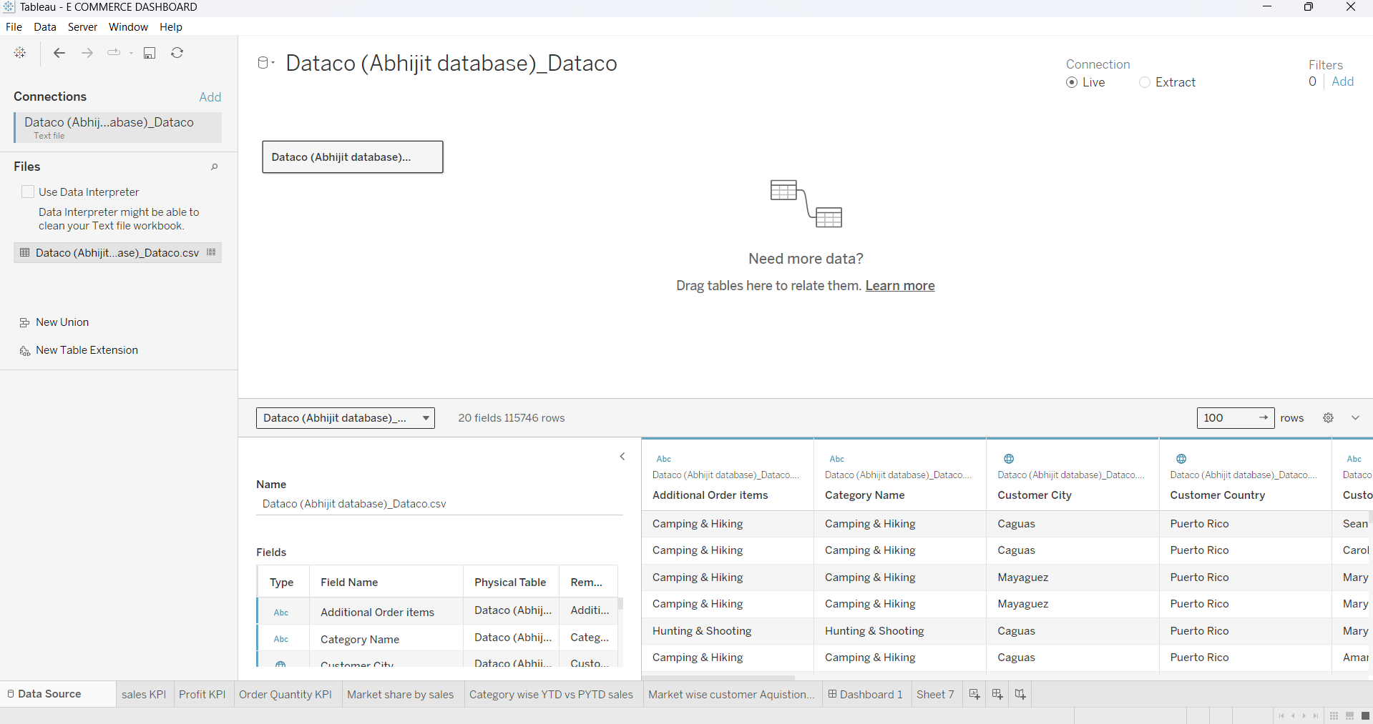

**Creating Worksheets:**

**Sales KPI**

1. Create a new worksheet.

2. Drag the Sales measure to the Text shelf.

3. Format the text to display the total sales and add a comparison with the previous year.

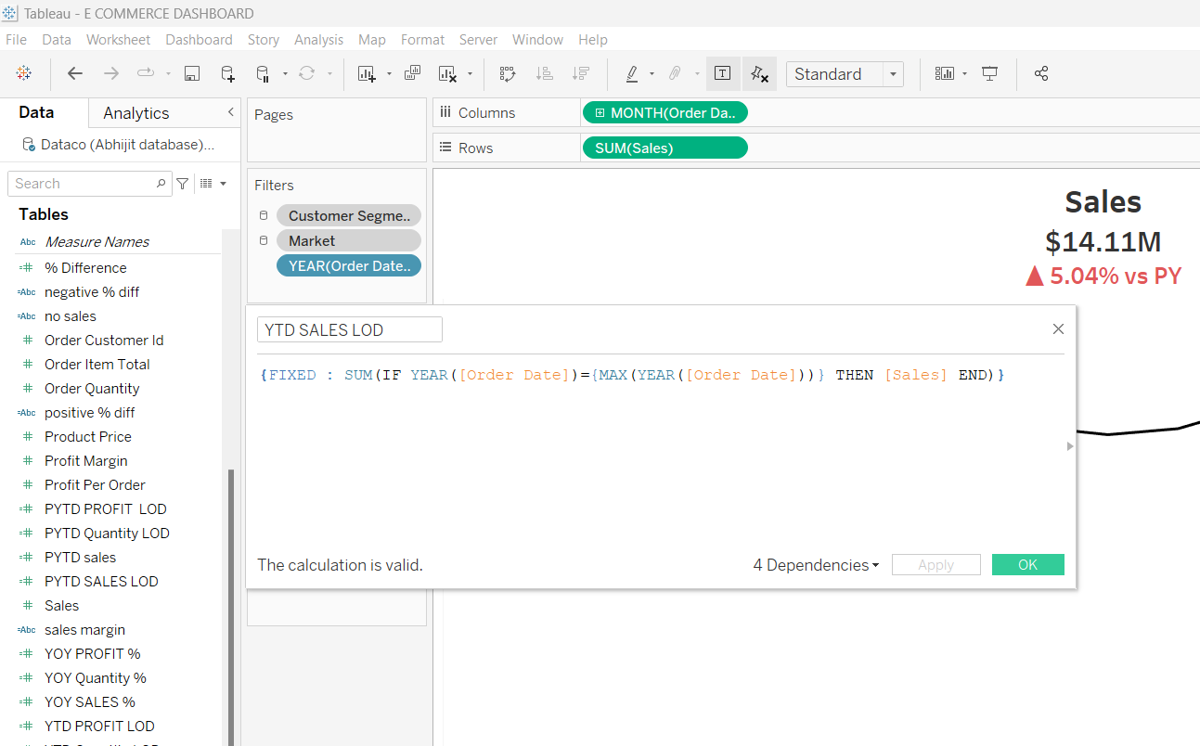

This is a calculation used to know the year-to-date sales of the market. We need many more calculations like these to build graphs and charts according to our requirements. These calculations will allow us to understand the data better. Since we know that “A picture can speak thousand words”.

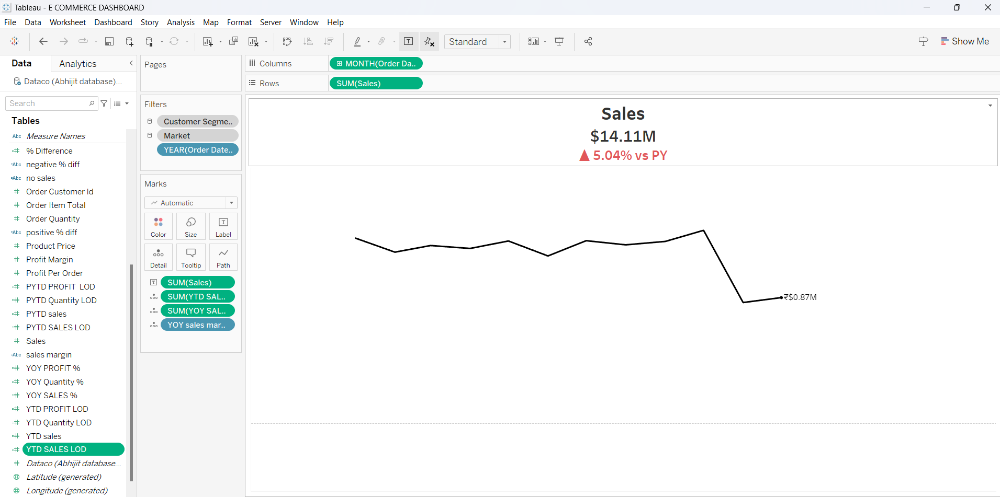

**Profit KPI**

1. Create a new worksheet.

2. Drag the Profit measure to the Text shelf.

3. Format the text to display the total profit and add a comparison with the previous year.

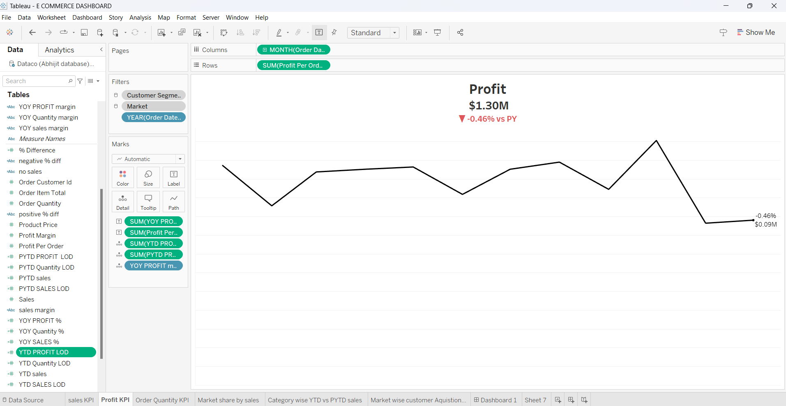

**Order Quantity KPI**

1. Create a new worksheet.

2. Drag the Order Quantity measure to the Text shelf.

3. Format the text to display the total order quantity and add a comparison with the previous year.

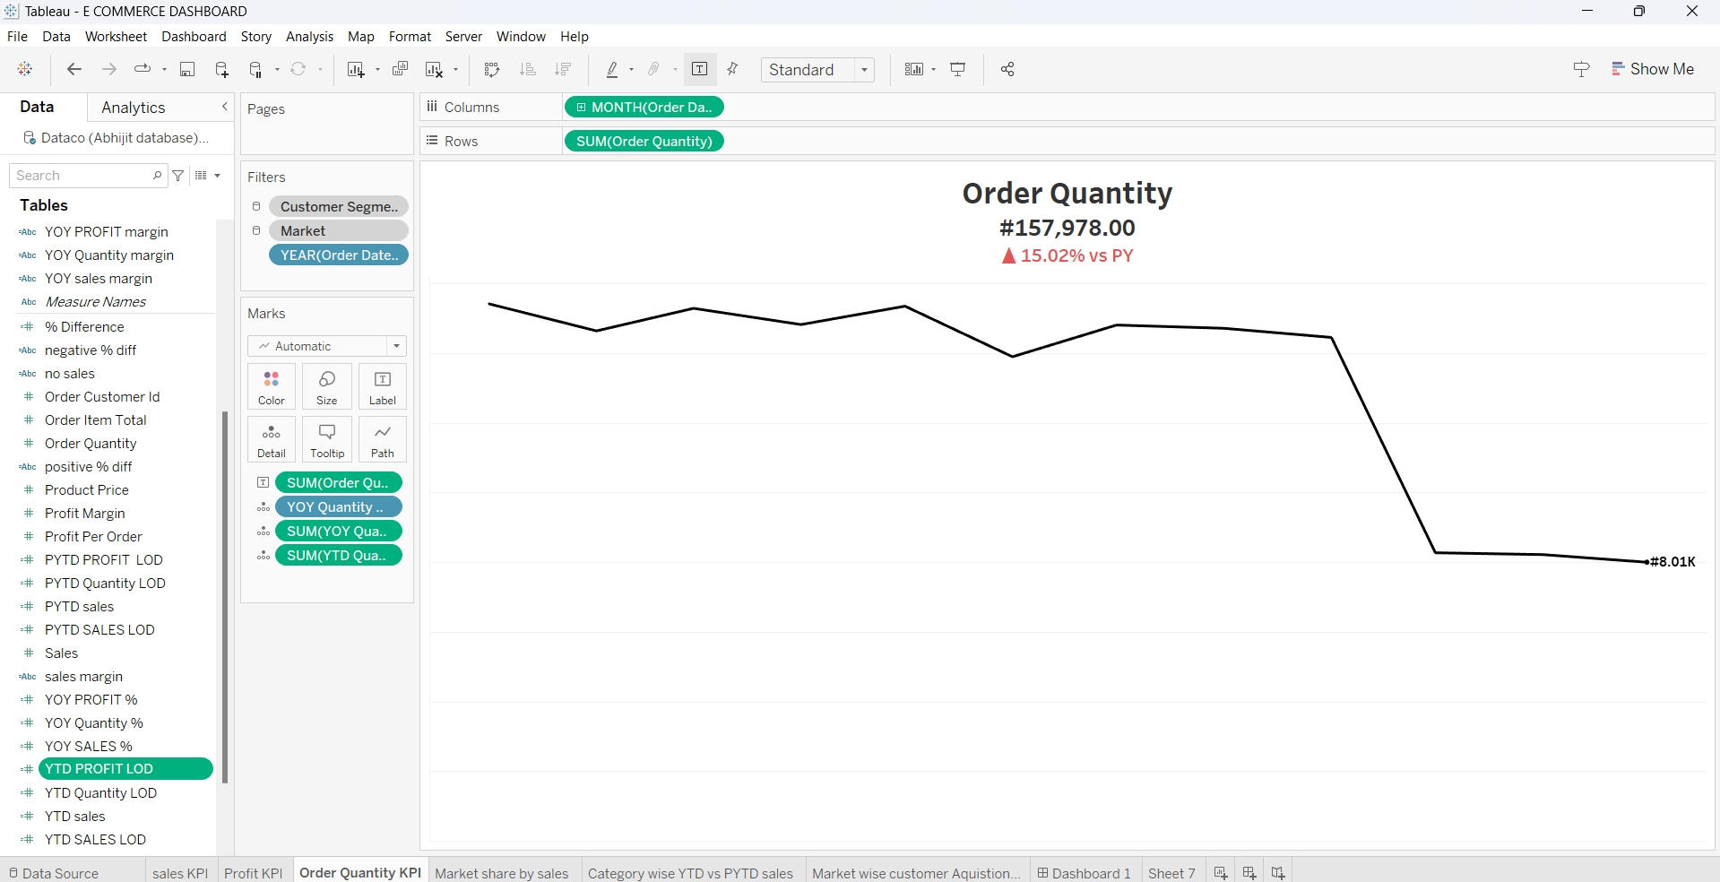

**Market Share by Sales**

1. Create a new worksheet.

2. Drag the Market dimension to the Columns shelf.

3. Drag the Sales measure to the Rows shelf.

4. Change the visualization to a pie chart.

5. Add labels to display the market share percentages.

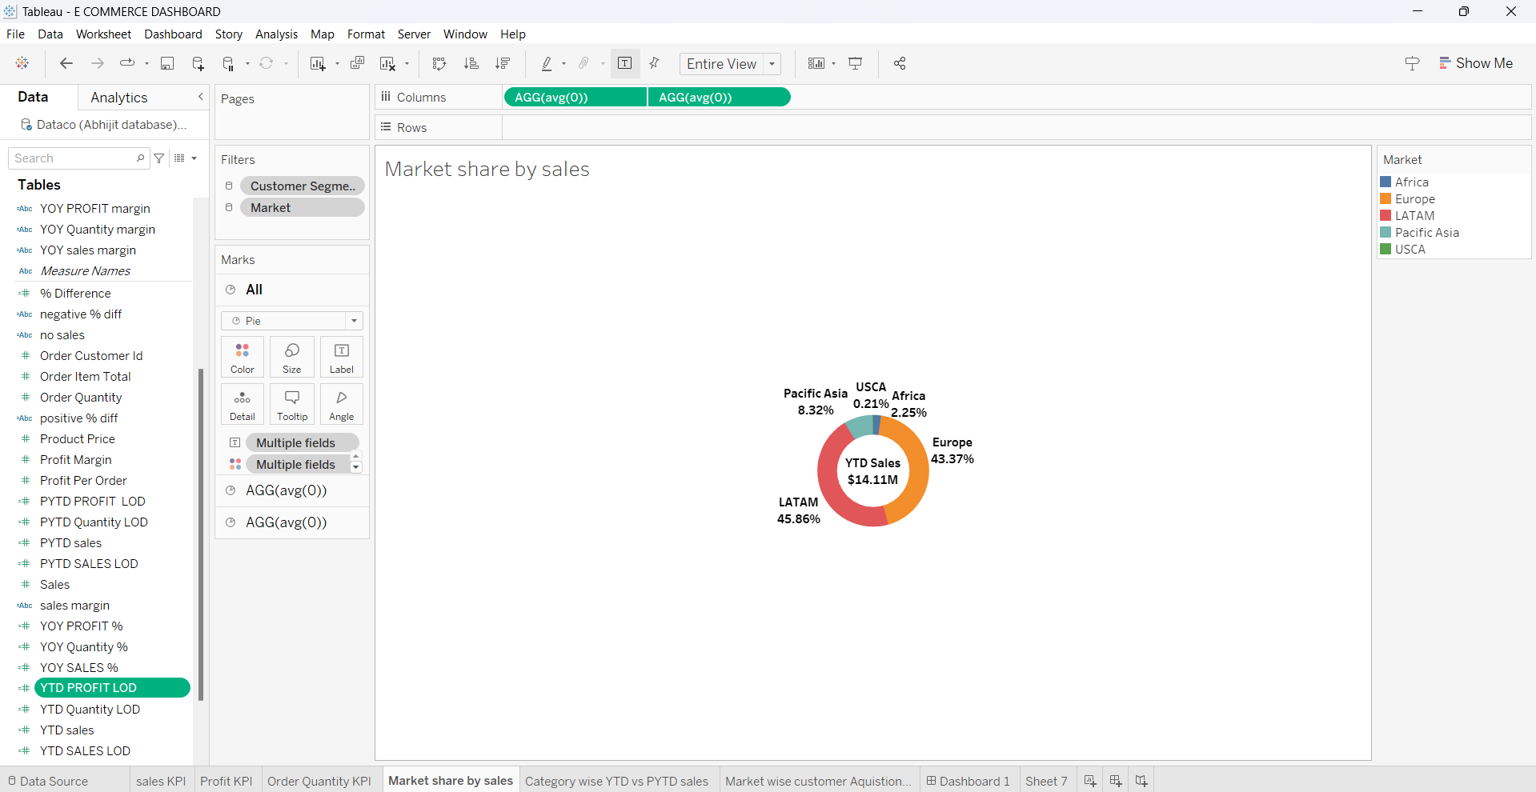

**Category-wise YTD vs PYTD Sales**

1. Create a new worksheet.

2. Drag the Category dimension to the Rows shelf.

3. Drag the Sales measure to the Columns shelf.

4. Add a calculated field to compare Year-to-Date (YTD) sales with Previous Year-to-Date (PYTD) sales.

5. Use a bar chart to display the comparison and color code the bars based on sales performance.

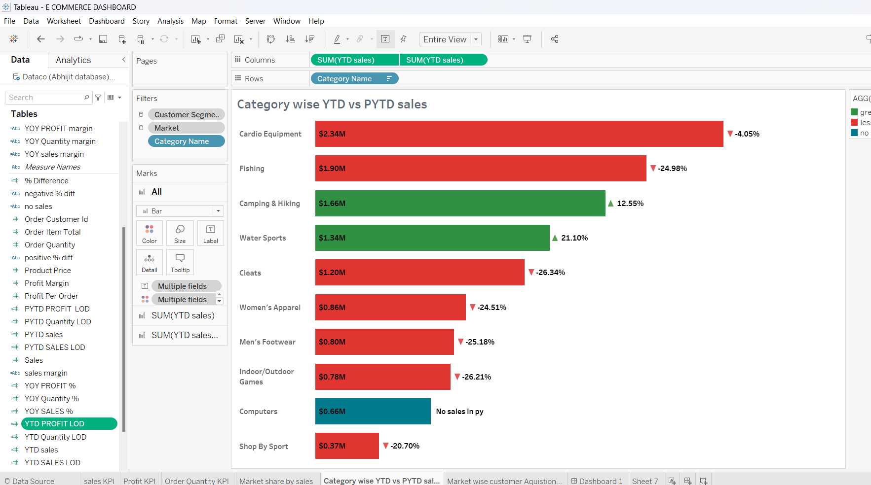

**Market-wise Customer Acquisition**

1. Create a new worksheet.

2. Drag the Market dimension to the Columns shelf.

3. Drag the Customer Acquisition measure to the Rows shelf.

4. Use a line chart to display the customer acquisition trends over months.

5. Add labels to highlight the ranks of markets per month.

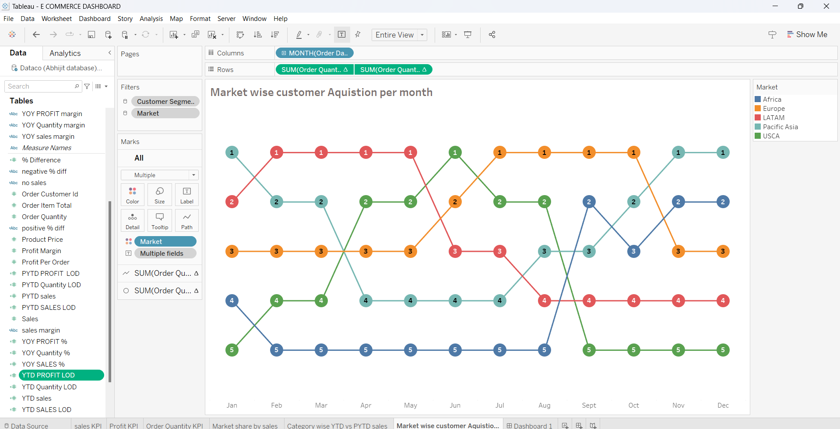

**RESULT**

**Creating the Dashboard:**

1. Create a new dashboard.

2. Drag and drop the previously created worksheets onto the dashboard.

3. Arrange the worksheets to create a cohesive layout, as shown in the provided screenshot.

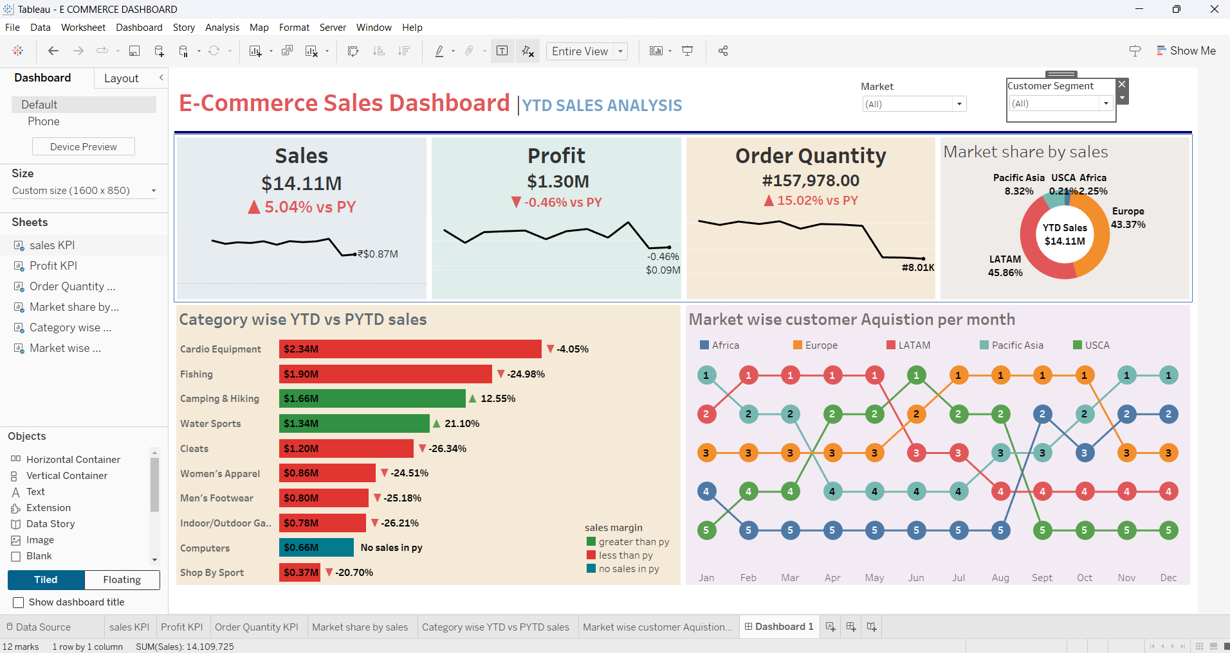

**Adding Filters and Interactivity:**

1. Add dropdown filters for Market and Customer Segment to allow users to interact with the dashboard.
2. Link the filters to the relevant worksheets to ensure they filter the data correctly across the entire dashboard.

**Final Adjustments and Formatting:**

1. Add titles and captions to the dashboard for better context.

2. Adjust the size and position of each element to ensure a clean and organized appearance.

3. Apply consistent formatting styles for fonts, colors, and borders.

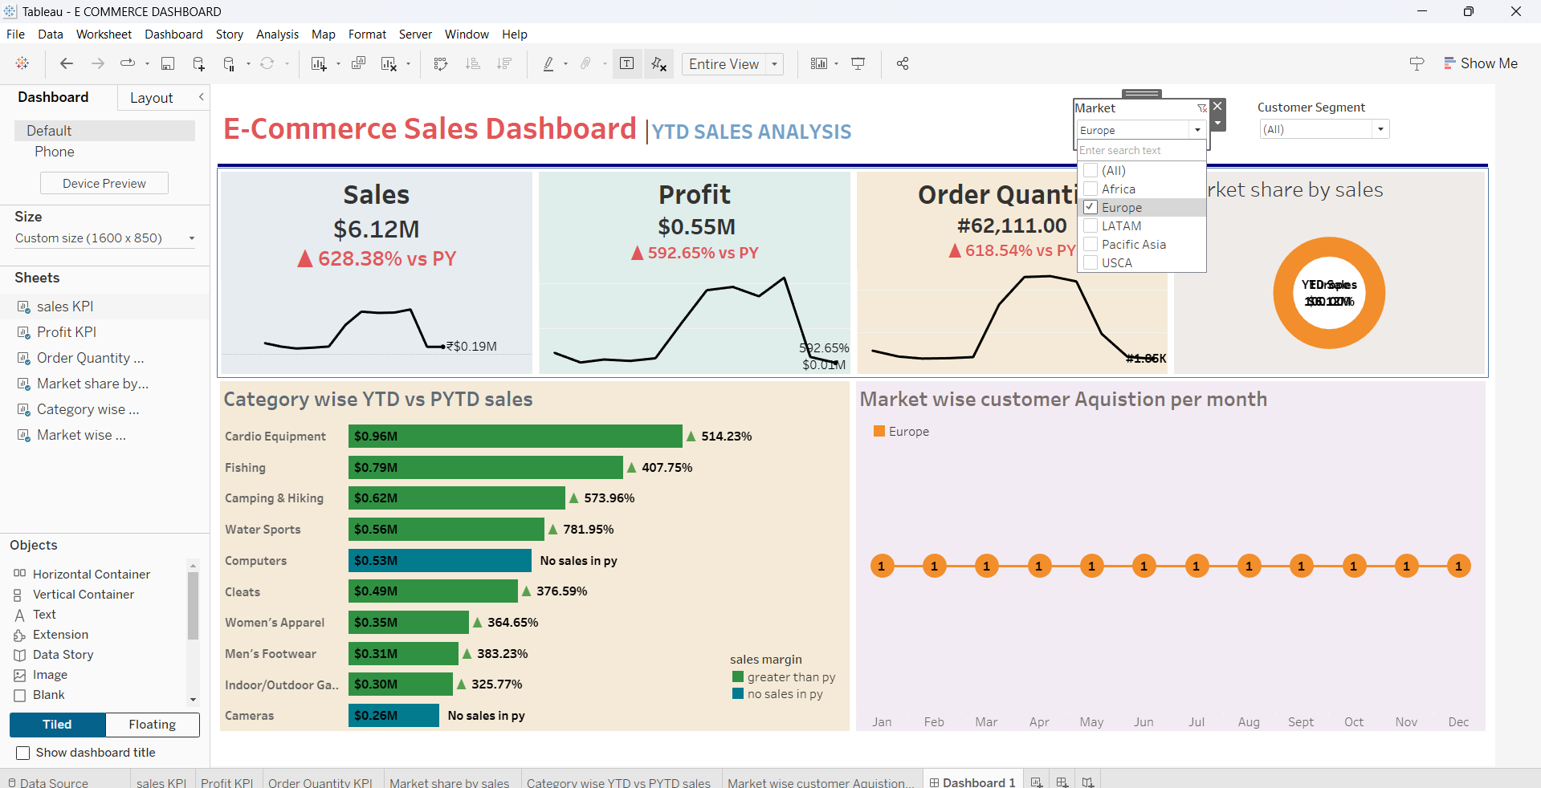+

By using the dropdown (Market), we can analyse the data from various regions.

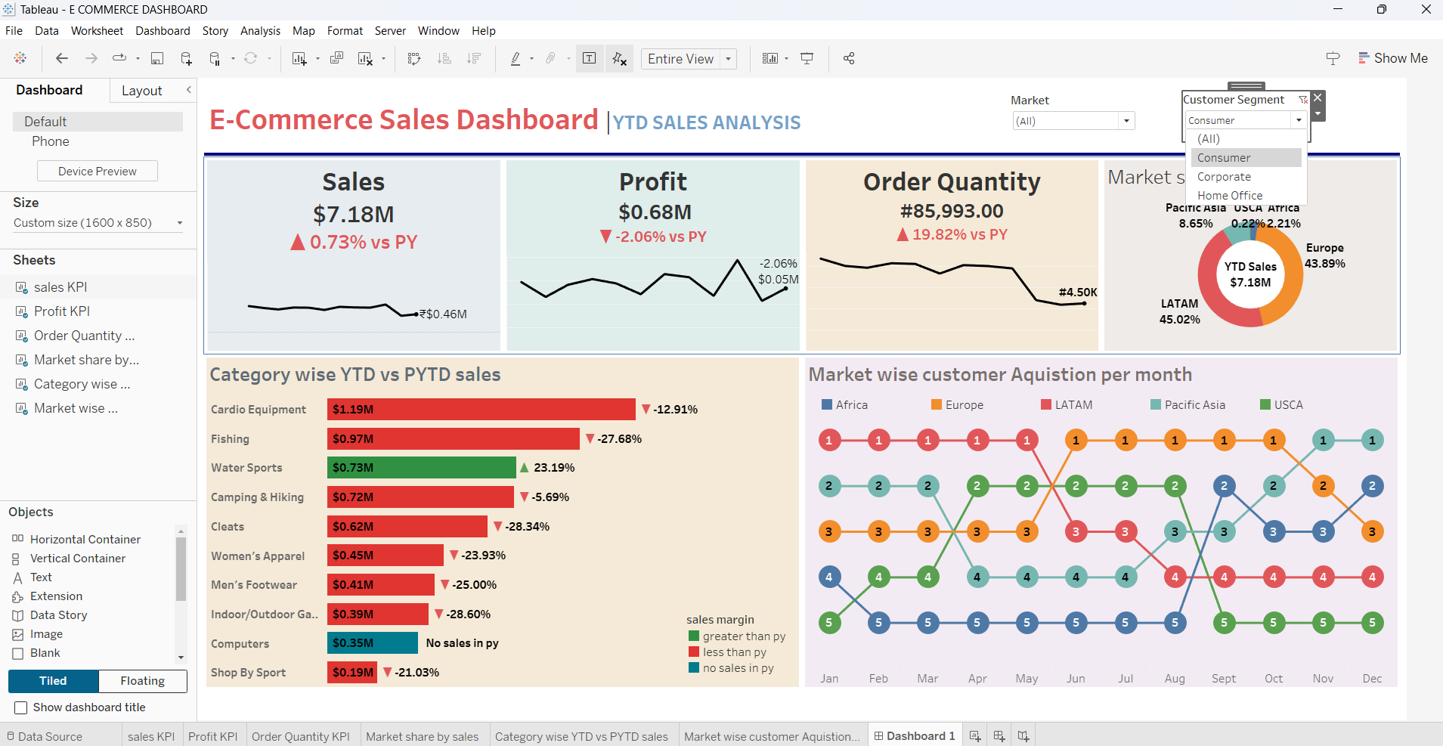

By using customer segment dropdown, we can analyse the data in different segments like customer, corporate and home office.

**CONCLUSION**

The e-commerce business has experienced mixed performance across various metrics and categories. The overall sales and order quantity have declined, indicating potential market challenges or changes in consumer behaviour. However, some product categories like Camping & Hiking and Water Sports have performed well, suggesting targeted opportunities for growth.

The market share data suggests a strong presence in Europe and LATAM, which can be leveraged for further expansion. The customer acquisition trends highlight the need to stabilize and enhance acquisition strategies, particularly in fluctuating markets like Europe and USCA.

**REFERENCES**

1. Tableau Software. (2023). Tableau Desktop Help. Retrieved from <https://help.tableau.com/current/pro/desktop/en-us/>
2. Murray, D. (2016). Tableau Your Data!: Fast and Easy Visual Analysis with Tableau Software. Wiley
3. Jones, B. (2014). Communicating Data with Tableau. O'Reilly Media.